Make a page like this:
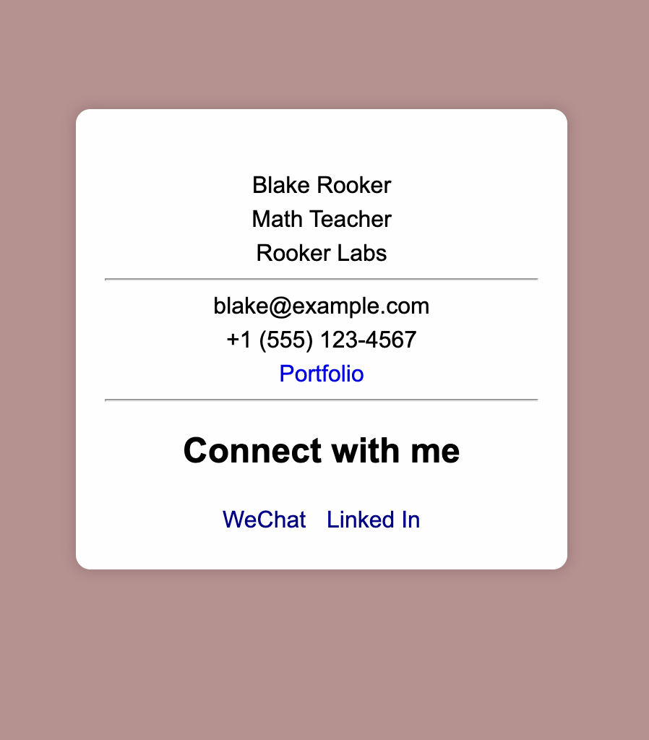

- You should link the style sheet styles.css using the link tag in the head section of the HTML file.
- Your page background should be rosybrown. The overall font should be Arial, with a fallback of sans-serif.
- All of the p elements should have a top and bottom margin of 5px.
- All links on the page should not be underlined.
- You should have a div with a class attribute with a value of business-card that will contain all the other elements.
- The .business-card selector should have properties to set the element as 300px wide and a background color of your choice. Also you should set a padding of 20px all around and a top margin of 100px. The text should be center aligned and the font size should be 16px. The left and right margins should be set to auto.
- Inside the .business-card element, there should be an img element with a class attribute with a value of profile-image. You can set the image source to https://cdn.freecodecamp.org/curriculum/labs/flower.jpg if you like. There should be an alt with a meaningful description.
- The .profile-image selector should have a max-width property with a value of 100%.
- Inside the .business-card element, after the img element, you should have three p elements with a class attribute that has, respectively, a value of full-name, designation, and company.
- The first p element should contain your name.
- The second p element should contain your designation.
- The third p element should have your company name.
- There should be an hr element below the third p element.
- After the hr element, there should be two p elements. In the first p element, you should have an email address as the text. In the second p element, the text should be a phone number.
- After the two p elements, there should be an a element with a class of portfolio-link, the text Portfolio, and it should link to a valid URL.
- There should be an hr element after the a element containing the portfolio link.
- You should have another div element with a class attribute with a value of social-media. Within this element, there should be an h2 element with the text Connect with me.
- Inside the .social-media elements, there should be three a elements. The a elements should have the text WeChat, LinkedIn respectively with links to valid websites.

My finished code:
Html:
<!DOCTYPE html>
<html lang="en">
<head>
<meta charset="UTF-8" />
<meta name="viewport" content="width=device-width, initial-scale=1.0" />
<title>Business Card</title>
<link rel="stylesheet" href="styles.css" />
</head>
<body>
<div class="business-card">
<img
class="profile-image"
src="https://cdn.freecodecamp.org/curriculum/labs/flower.jpg"
alt="Profile image of a flower"
/>

<p class="full-name">Blake Rooker</p>
<p class="designation">Math Teacher</p>
<p class="company">Rooker Labs</p>

<hr />

<p>blake@example.com</p>
<p>+1 (555) 123-4567</p>

<a class="portfolio-link" href="https://example.com" target="_blank">Portfolio</a>

<hr />

<div class="social-media">
<h2>Connect with me</h2>
<a href="https://wechat.com" target="_blank">WeChat</a>
<a href="https://linkedin.com" target="_blank">Linked In</a>
</div>
</div>
</body>
</html>

CSS:
body {
background-color: rosybrown;
font-family: Arial, sans-serif;
}

p {
margin-top: 5px;
margin-bottom: 5px;
}

a {
text-decoration: none;
}

.business-card {
width: 300px;
background-color: #fefefe;
padding: 20px;
margin: 100px auto 0 auto;
text-align: center;
font-size: 16px;
border-radius: 10px;
box-shadow: 0 0 10px rgba(0, 0, 0, 0.2);
}

.profile-image {
max-width: 100%;
border-radius: 8px;
}

.social-media {
margin-top: 10px;
}

.social-media a {
display: inline-block;
margin: 5px;
color: darkblue;
}

